Talisay Beach Resort Smart Tourism System: A Web and Mobile Booking Platform with Chatbot Support

A Capstone Project Proposal
Presented to the Faculty of the
Information and Communications Technology Program
STI College Ormoc

In Partial Fulfilment
of the Requirements for the Degree
Bachelor of Science in Information Technology
Louie Jay M. Calacat
Klint Joshua A. Ellar
Kier Loui R. Morfe
Ivan O. Pagadora

May 21, 2026

ENDORSEMENT FORM FOR PROPOSAL DEFENSE

TITLE OF RESEARCH: Talisay Beach Resort Smart Tourism System: A Web
and Mobile Booking Platform with Chatbot Support

NAME OF PROPONENTS: Louie Jay M. Calacat
Klint Joshua A. Ellar
Kier Loui R. Morfe
Ivan O. Pagadora

In Partial Fulfilment of the Requirements
for the degree Bachelor of Science in Information Technology
has been examined and is recommended for Proposal Defense.

ENDORSED BY:

Rona Mira B. Lucañas
Capstone Project Adviser

APPROVED FOR PROPOSAL DEFENSE:

Rona Mira B. Lucañas
Capstone Project Coordinator

NOTED BY:

Rona Mira B. Lucañas
Program Head

May 21, 2026

APPROVAL SHEET
This capstone project proposal titled Talisay Beach Resort Smart Tourism System: A Web and Mobile Booking Platform with Chatbot Support, prepared and submitted by Louie Jay M. Calacat, Klint Joshua A. Ellar, Kier Loui R. Morfe and Ivan O. Pagadora, in partial fulfillment of the requirements for the degree of Bachelor of Science in Information Technology, has been examined and is recommended for acceptance and approval.
Rona Mira B. Lucañas
Capstone Project Adviser
Accepted and approved by the Capstone Project Review Panel
in partial fulfillment of the requirements for the degree of
Bachelor of Science in Information Technology

Elizabeth L. Dumaran | Rona Mira B. Lucañas
Panel Member | Panel Member

Engr. Sheena Joy S. Muyuela
Lead Panelist

Noted:
Rona Mira B. Lucañas | Rona Mira B, Lucañas
Capstone Project Coordinator | Program Head

May 21, 2026

TABLE OF CONTENTS
 |  | Page
Title Page |  | i
Endorsement form for Proposal Defense |  | ii
Approval Sheet |  | iii
Table of Contents |  | iv
Introduction
 | Project Context | 1
 | Purpose and Description | 2
 | Objectives | 3
 | Scope and Limitations  Review of Related Literature/Studies/Systems | 5  7
Methodology
 | Technical Background | 9
 | Requirements Analysis | 12
 | Requirements Documentation | 13
 | Design of Software, System, Product, and/or Processes | 18
References |  | 21
Appendices |  | 23
 | Resource Persons | 24
 | Personal Technical Vitae | 27

INTRODUCTION
Project Context

Digital technology has completely changed how people plan their vacations and book tourism services. Today, travelers look for fast, simple, and convenient online systems that let them make reservations, get updates, and find customer support directly through their mobile phones or computers.
Talisay Beach, located in Barangay Maslug, Baybay City, Leyte, is becoming a highly popular destination because of its relaxing atmosphere, clear waters, and unique rocky shoreline. However, the beach resort still relies heavily on traditional, manual booking methods like walk-in reservations and phone calls. These old processes frequently lead to serious issues, including booking conflicts, overbooking, delayed confirmations, and difficulties tracking customer requests.
To solve these problems and modernize the destination, we designed the Talisay Beach Smart Tourism System. This platform includes a central web application for administrators and an easy-to-use mobile application for tourists. On top of standard online reservations and automated chatbot support, the system incorporates advanced safety, engagement, and exploration features: an Emergency Assistance Module for quick on-site safety responses, a Tourist Memory Timeline that auto-generates downloadable digital scrapbooks, and a Virtual 360-Degree Tour that lets users explore the beach before arriving. By putting these tools into one system, the platform makes operations much smoother for staff while giving tourists a modern, helpful, and highly interactive experience.

Purpose and Description
The primary purpose of this project is to create the Talisay Beach Smart Tourism System to upgrade the reservation, safety, and visitor experience at Talisay Beach in Barangay Maslug, Baybay City, Leyte.
The system provides a web dashboard for management and a mobile app for guests to speed up bookings, prevent double bookings, and eliminate manual errors. Key modules allow tourists to check live availability, secure reservations, process digital payments, and get instant answers from a chatbot. To offer a more comprehensive solution, the system also features an instant emergency alert tool for guest safety, an automated photo timeline to preserve guest memories, and a 360-degree virtual tour feature to boost digital marketing and trip planning.

Objectives

The general objective of this study is to design and develop the Talisay Beach Smart Tourism System, a web and mobile platform featuring real-time booking, secure online payments, an automated chatbot, and interactive tourist modules to elevate safety, engagement, and convenience for visitors in Baybay City, Leyte.

Specifically, the study aims to:
- Cross-Device Applications: Develop a responsive web platform for administrators to run operations and a user-friendly mobile app for tourists to access services on the go.
- Smart Booking Engine: Create a live reservation module that checks availability in real-time, detects scheduling conflicts, and manages cancellations smoothly.
- Payment Integration: Integrate secure online payment options for fast transactions and automatic financial tracking.
- 24/7 Chatbot Support: Design a rule-based intelligent chatbot to handle FAQs and guide users through booking questions instantly at any hour.
- Emergency Assistance: Implement an instant alert feature in the mobile app that routes urgent medical, security, or lost-item requests directly to staff dashboards for quick on-site coordination.
- Memory Timeline: Build an automated scrapbook feature that compiles a guest’s photos, activities, and logs into a downloadable digital vacation album.
- Virtual Exploration: Embed a 360-degree virtual tour module that lets users interactively explore the beach and facilities before booking.
- Feedback & Analytics: Incorporate a review system for guest feedback and a central dashboard for administrators to monitor reports and capacity.

Scope and Limitations
User levels
- Administrator: Has full control over the system. They manage beach services, adjust packages, modify pricing, audit online payments, handle user accounts, and view complete business reports.
- Tourism Staff / Operator – Monitors daily booking schedules, checks guest reference IDs, tracks live visitor capacity, and responds immediately to emergency alerts generated by guests.
- Tourist (User/Client) – Can register an account, interactively view the resort via the 360-degree tour, book packages, make online payments, use the chatbot, trigger emergency alerts, and view or download their personalized memory timeline.
Platform Accessibility
Both the web dashboard and the mobile app connect to a single, centralized database to keep all information synchronized in real-time. For example, when a tourist books a package or submits an emergency alert on their mobile app, the update is instantly visible on the web dashboard. This instant sync prevents scheduling conflicts like double bookings and allows the beach staff to manage daily operations and respond to guest needs immediately from any device.

Administrator Functions (Web-Based)
- File Maintenance: Easily add, change, or remove beach services, rental packages, pricing rates, and user profiles.
- Transactions & Operations: Monitor incoming bookings, check real-time beach capacity limits, verify digital payments, look up booking reference IDs, and handle active emergency alerts from guests.
- Reports: Automatically generate organized summaries for reservations, cancellations, total revenue, and visitor feedback.
- Utilities: Manage system-wide notifications, set daily visitor capacity caps, adjust open availability schedules, and review chatbot conversation histories.
Guest Functions (Web and Mobile)
- Account Access: Register a new account and log in securely to save personal profiles and trip data.
- Discovery & Booking: View detailed information about the resort and interactively explore the beach facilities using the 360-Degree Virtual Tour feature before booking.
- Smart Booking: Select packages and reserve slots based on live, real-time availability calendars.
- Payment & Transaction Updates: Pay safely online through integrated digital options and get automated updates regarding booking statuses.
- On-Site Support: Chat with the automated chatbot 24/7 for fast answers to FAQs, or use the Emergency Assistance Module to send immediate help requests to staff for medical, security, or lost-item issues.
- History & Feedback: Review past booking logs and submit post-visit ratings. and view or download a personalized digital scrapbook via the Tourist Memory Timeline.

Limitations
- The system is limited to Talisay Beach in Barangay Maslug, Baybay City, Leyte and does not cover other tourist destinations.
- The system focuses on beach booking, reservation, and chatbot support.
- Online payment is limited to selected integrated payment methods supported by the system.
- The chatbot is primarily rule-based with possible future AI enhancements.
- The system requires internet connectivity and does not support full offline functionality.
- The 360-degree tour relies on pre-recorded panoramic imagery and does not stream live video feeds.
- The system is accessible through both web and mobile platforms; however, functionality may vary slightly depending on the device used.
- The system does not directly process transportation bookings or ride-hailing transactions, as transportation features are limited to informational support only.

Review of Related Literature/Studies/Systems
Related Literature
- Development of a Web-Based Reservation and Management System for Local Resorts: Ramento et al. (2024) developed a web-based reservation system focused on real-time booking and availability management. The system successfully reduced scheduling conflicts and improved operational efficiency for resort administrators. However, its limitation lies in the absence of a mobile application and chatbot integration, restricting tourist accessibility on the go.
- Mobile-Based Booking Application for Beach Resort: Santos and Rivera (2023) created a mobile application for a beach resort in Cebu that includes online booking, payment integration, and SMS confirmation. The study showed improved customer convenience. A key limitation, however, is that it did not incorporate automated chatbot support or advanced scheduling conflict detection for complex bookings.
- Tourism Management System with Chatbot Integration: Abad et al. (2025) implemented a web-based tourism system with an integrated chatbot for a municipal tourism office. The chatbot effectively handled customer inquiries and basic reservations. One drawback is that the system was limited strictly to a web platform, missing out on mobile convenience and real-time conflict prevention features.
- Resort Reservation System with Payment and Reporting Features: Dela Cruz (2024) developed a reservation system for a resort in Leyte that focused on payment processing, booking management, and administrative reporting. The system helped reduce manual workload. An evident gap in this system is the complete lack of mobile application support and direct chatbot functionality for tourists.

METHODOLOGY
Technical Background
To build a fast, secure, and responsive platform that serves both administrators and tourists seamlessly, the proponents carefully selected a modern, industry-standard tech stack. This ecosystem integrates frontend interfaces, robust backend logic, centralized databases, and cross-platform mobile development tools into a single, cohesive solution.
The specific technologies chosen to develop and power the platform include:
Development Environment & Database Management
- XAMPP: Utilized as the primary local development environment to safely build, test, and preview application updates before deployment.
- MySQL: Serving as the central relational database management system, MySQL securely stores and organizes critical data, including user profiles, booking schedules, payment records, and system logs.
- Frontend & User Interface (UI) Design
- HTML5, CSS3, Bootstrap, and Tailwind CSS: Combined to structure and design the web platform's presentation layer. Bootstrap and Tailwind CSS ensure that the user interface is completely responsive, adapting beautifully to any screen size from desktop monitors to mobile displays.
- JavaScript: Employed to handle dynamic client-side interactions, such as real-time availability checks and interactive 360-degree virtual tour views, and showing instant emergency alerts on the staff dashboard without needing to refresh the page.
Backend Logic & Mobile Development
- PHP with Laravel Framework: Chosen to drive the core backend architecture. Laravel handles the system's heavy lifting, managing complex business logic, real-time scheduling conflict detection, secure request processing, automatically putting together the tourist memory timelines, and routing emergency notifications to staff instantly.
- Flutter: Selected to build the mobile side of the platform. Using Flutter allows the proponents to compile a single codebase into native, high-performance mobile applications for both Android and iOS devices, maximizing tourist reach.
- Visual Studio Code: Used as the primary Integrated Development Environment (IDE) to write, debug, and manage the project's source code.
Automated Customer Support
- Dialogflow / Custom Chatbot Engine: Powers the intelligent conversational agent embedded within the system. This technology enables 24/7 automated guest support, instantly answering FAQs and guiding users through basic booking inquiries.

Calendar of Activities
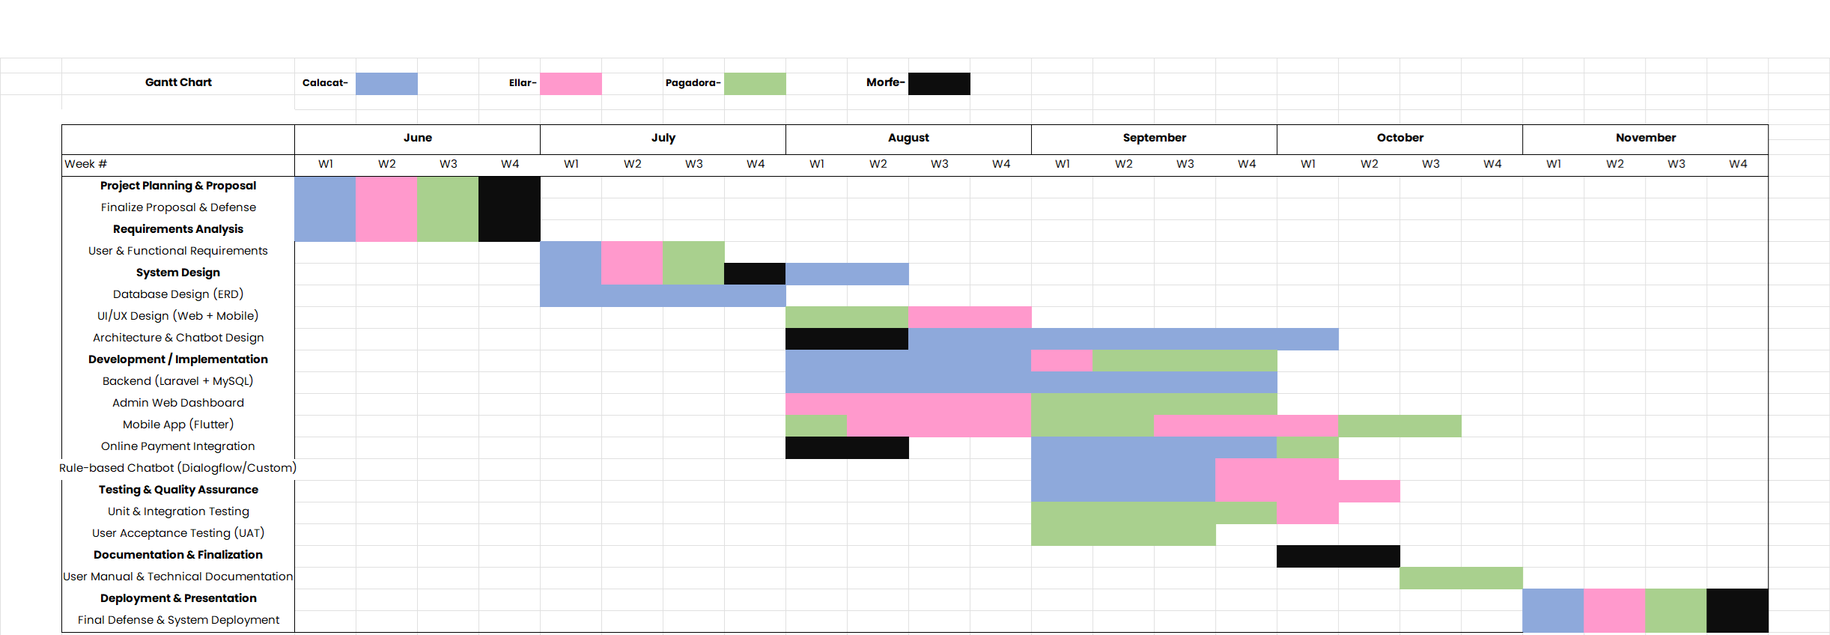
The capstone project spans a 6-month period from June to November, broken down into weekly milestones for each member.

Figure 1: Gantt Chart

Requirements Analysis
Fixes Applied: Restructured from a heavy paragraph format into a highly scannable bullet structure based on targeted user personas.
The system replaces traditional manual booking methods with an automated and centralized platform, resulting in fewer errors, faster processing, and better overall management of Talisay Beach tourism activities. To ensure smooth operations, the platform handles specific workflows for three primary groups:
- Tourists
  - Browse available beach packages and open time slots.
  - Book reservations and pay online securely.
  - Ask questions through the chatbot and submit feedback post-visit.
- Tourism Staff & Operators
  - Track daily bookings and customer reservations.
  - Monitor real-time beach capacity thresholds.
- Administrators
  - Update beach services, scheduling parameters, and pricing.
  - Manage system user access and confirm payment audits.
  - Generate operational reports for long-term business tracking.

Requirements Documentation
This section translates the project workflows into concrete technical specifications. It outlines the specific functionalities the system must execute and the quality standards it must meet to ensure a reliable user experience.
Functional Requirements
Functional requirements define the core features and actions that the Talisay Beach Smart Tourism System must perform for its users.
1. Guest & Tourist Features (Mobile App)
- Account Management: The system must allow tourists to register an account, securely log in, and manage their user profiles.
- Real-Time Booking: Users must be able to browse available packages, view live calendar slots, and submit reservations.
- Payment Processing: The system must integrate with secure gateways to process digital payments and instantly update booking statuses.
- Automated Support: The system must host a rule-based chatbot capable of answering FAQs and assisting with bookings 24/7.
- Feedback Mechanism: The system must allow users to submit ratings and written reviews after completing a visit.

2. Staff & Operator Features (Web Dashboard)
- Booking Monitor: Operators must have access to a live feed of all daily reservations and booking reference IDs.
- Capacity Tracking: The system must automatically calculate and display current beach capacity thresholds to prevent overcrowding.
3. Administrator Features (Central Web Portal)
- Content Management (File Maintenance): Administrators must be able to add, update, or remove beach services, packages, pricing, and system accounts.
- Audit & Verification: The system must provide tools for administrators to verify digital payment receipts and audit transactions.
- Report Generation: The dashboard must generate structured summaries and downloadable reports on revenue, reservation trends, cancellations, and guest feedback.

Requirements Documentation
DESIGN MODEL
MANUAL PROCESS (Client Side)
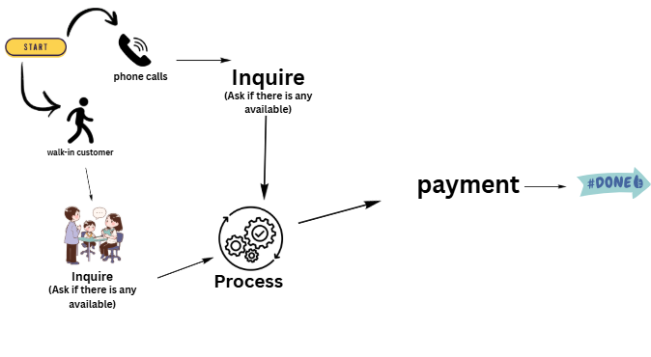

MANUAL PROCESS (Admin Side)
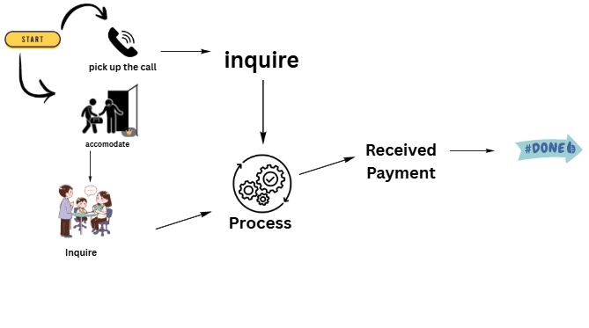

PROPOSED PROCESS (Client Side)

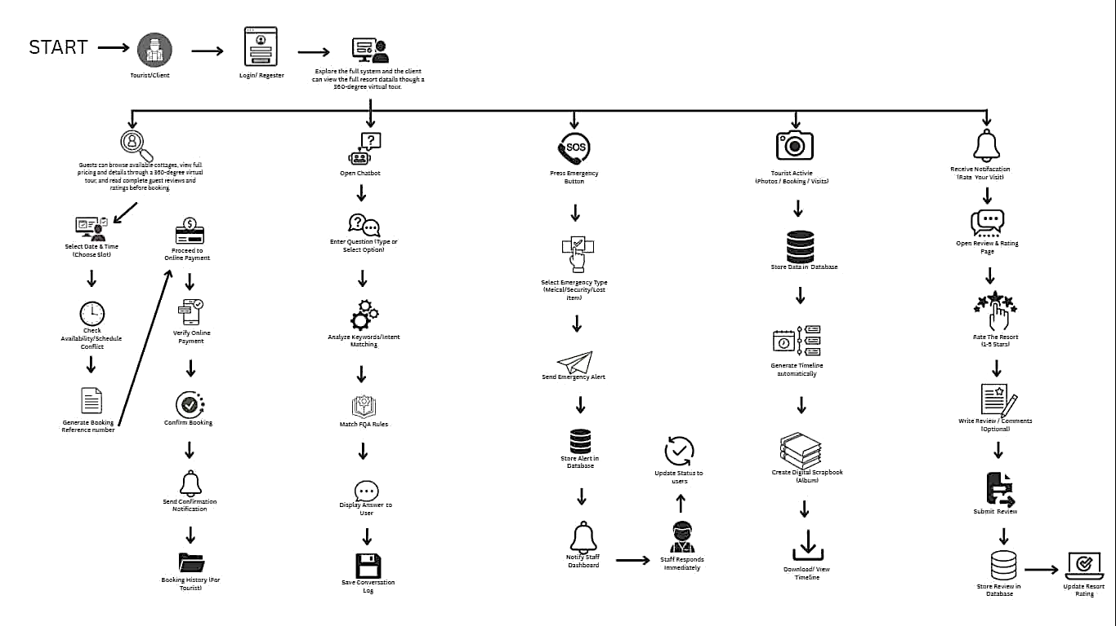

PROPOSED PROCESS (Admin Side)

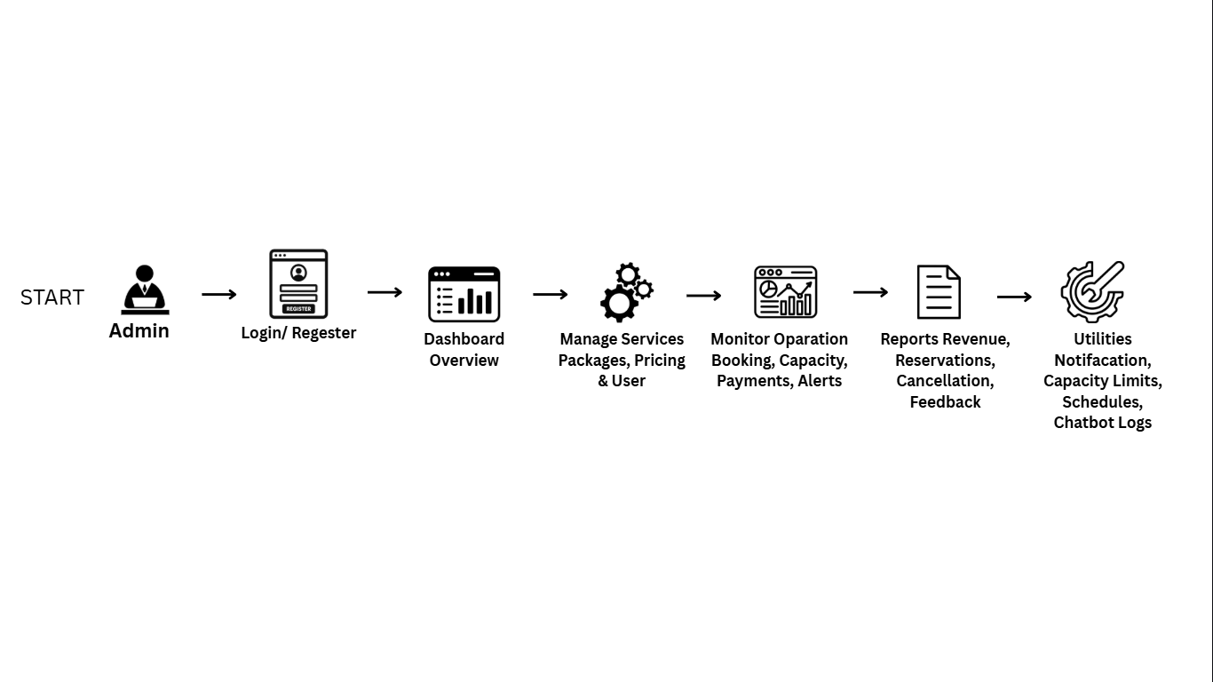

PROPOSED PROCESS (Staff Side)

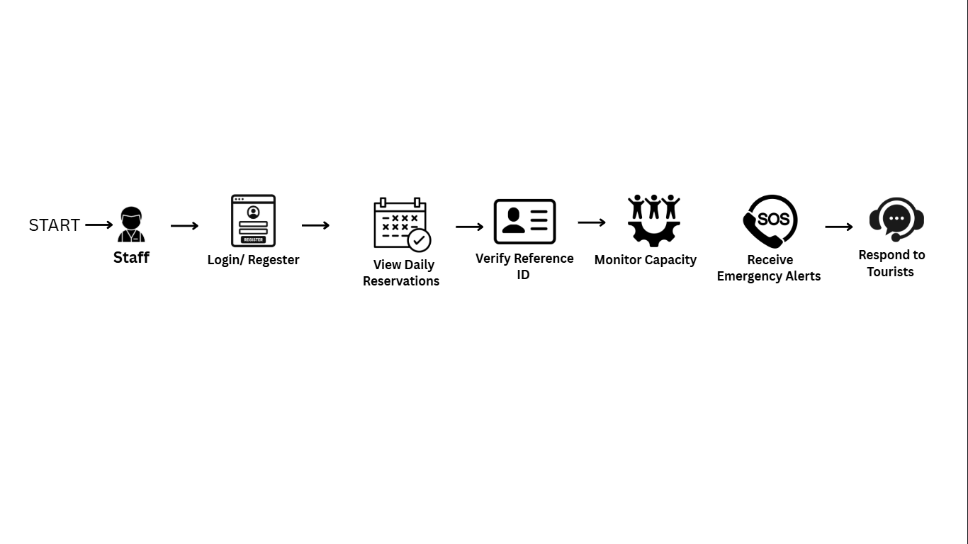

Design of Software, System, Product, and/or Processes
This section details the structural design, data relationships, and operational processes of the Talisay Beach Smart Tourism System. It illustrates how the different components of the web and mobile platforms interact with the centralized database to deliver a cohesive user experience.
System Architecture
The platform utilizes a Client-Server Architecture powered by a centralized cloud database to guarantee real-time data synchronization. The system is split into two primary components:
- Frontend Layer: The tourist mobile app is built using Flutter for fast performance on both Android and iOS devices. The administrative dashboard is created using HTML5, CSS3, Bootstrap, and Tailwind CSS for a fully responsive layout.
- Frontend Layer: The tourist mobile app is built using Flutter for fast performance on both Android and iOS devices. The administrative dashboard is created using HTML5, CSS3, Bootstrap, and Tailwind CSS for a fully responsive layout.
- Database Layer: A centralized MySQL database securely houses all profile records, schedule calendars, payment data, media links, and interaction logs.
System Conceptual Framework
The system operates on an Input-Process-Output (IPO) model, mapping out how user interactions turn into completed services.
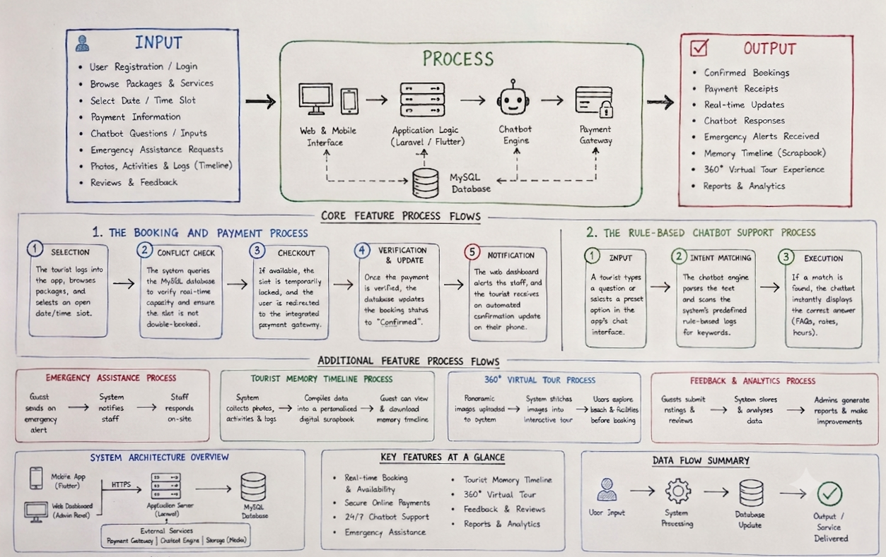
Core Process Flows
To give you a clear picture of how the software handles background logic, here are the step-by-step processes for the system's two most critical features:
The Booking and Payment Process
- Selection: The tourist logs into the mobile app, browses packages, and selects an open date/time slot.
- Conflict Check: The system queries the MySQL database to verify real-time capacity and ensure the slot is not double-booked.
- Checkout: If available, the slot is temporarily locked, and the user is redirected to the integrated payment gateway.
- Verification & Update: Once the payment is verified, the database updates the booking status to "Confirmed".
- Notification: The web dashboard alerts the staff, and the tourist receives an automated confirmation update on their phone.
The Rule-Based Chatbot Support Process
- Input: A tourist types a question or selects a preset option in the app's chat interface.
- Intent Matching: The chatbot engine parses the text and scans the system's predefined rule-based logs for keywords.
- Execution: If a match is found, the chatbot instantly displays the correct answer (FAQs, rates, hours).

REFERENCES
Abad, J. M., Cruz, R. T., & Lopez, M. A. (2025). Development of a tourism management system with integrated chatbot for local destinations.
Booking Holdings Inc. (2024). The future of digital booking in tourism. https://www.booking.com
Dela Cruz, A. B. (2024). Online reservation system for beach resorts in Leyte (Unpublished undergraduate thesis). Visayas State University, Baybay.
Garcia, R. P., & Mendoza, S. L. (2024). Smart tourism applications in Eastern Visayas: Challenges and opportunities. Philippine Journal of Tourism Research, 7(1), 34–48.
Kumar, V., & Singh, P. (2023). Role of mobile applications in enhancing tourist experience. Journal of Hospitality and Tourism Technology, 14(2), 156–172.
Ramento, C. L., Garcia, P. R., & Santos, J. D. (2024). Web-based reservation system for small tourism businesses. Journal of Information Technology and Tourism, 12(3), 45–58.
Santos, M. E., & Rivera, L. C. (2023). Mobile application for beach resort booking and management. Philippine Journal of Information Systems, 8(2), 112–125.
Smith, J., & Johnson, A. (2023). Chatbot applications in modern tourism services. International Journal of Hospitality Management, 45, 78–89.
TripAdvisor. (2024). The impact of online reviews and booking systems on small tourism destinations. https://www.tripadvisor.com
Villanueva, K. A., & Torres, R. B. (2025). Digital transformation of tourism in Leyte province (Unpublished capstone project). STI College Ormoc.
World Tourism Organization. (2024). Advancing digital solutions for sustainable tourism in local communities. United Nations World Tourism Organization.
Zhang, L., & Wang, H. (2024). Artificial intelligence and chatbots in smart tourism: A systematic review. Tourism Management Perspectives, 51, 101–112.

APPENDICES

APPENDIX A. RESOURCE PERSONS
Name: Jeanet Reusora Morfe
Position: Owner
Company Name: Talisay Beach Resort
Email: jeanetreusoramorfe@famil.com

Questionnaires
1. Questions for the Resort Owner (The Business Side)
- How do you handle bookings right now?
- What happens when two different guests try to book the same room or cottage at the same time?
- How long does it take you to check your records and confirm a guest's payment?
- When a guest has an emergency on the beach, how do they contact your staff right away?

APPENDIX B. PERSONAL TECHNICAL VITAE



Curriculum Vitae of
LOUIE JAY M. CALACAT
Brgy. Esperanza, Pilar
LouieJaycalacat@gmail.com
09631180498

EDUCATIONAL BACKGROUND
Level | Inclusive Dates | Name of school/ Institution
Tertiary | 2023-present | STI College Ormoc
Vocational/Technical | 2021-2023 | Pilar National High School
High School | 2017-2021 | Pilar National High School
Elementary | 2011-2017 | Esperanza Elementary School

AFFILIATIONS
Inclusive Dates | Name of Organization | Position
2022-Present | STI IT GUILD | Member
Listed in reverse chronological order (most recent first).
SKILLS
SKILLS | Level of Competency | Date Acquired
Programing Languages-  Python, Java, CSS, PHP | Intermediate | January 2024
Database- MySql  Esport Player (MLBB) | Basic  Intermediate | January 2024  June 2020

TRAININGS, SEMINARS, OR WORKSHOPS ATTENDED
Inclusive Dates | Title of Training, Seminar, or Workshop
SEPT 2025 | Blockchain Tech Workshop on Coding Smart Contracts in CashScript
 | Cyber Security Awareness- STI College Ormoc
Listed in reverse chronological order (most recent first).



Curriculum Vitae of
KLINT JOSHUA A. ELLAR
Brgy. Calubian, Baybay Leyte
Klintjoshua97@gmail.com
09243624152

EDUCATIONAL BACKGROUND
Level | Inclusive Dates | Name of school/ Institution
Tertiary | 2022- Present | STI College Ormoc
Vocational/Technical | 2020-2022 | Baybay City Senior High School
High School | 2016-2020 | FCIC
Elementary | 2010-2016 | CPJ Elementary School

AFFILIATIONS
Inclusive Dates | Name of Organization | Position
2022-Present | STI IT GUILD | Member
Listed in reverse chronological order (most recent first).

SKILLS
SKILLS | Level of Competency | Date Acquired
Programming Languages -  PHP, C#, Java, Python, | Basic | 2023
Database - MySql, | Basic | 2022
Esports Player (MLBB) | Amateur | 2020

TRAININGS, SEMINARS, OR WORKSHOPS ATTENDED
Inclusive Dates | Title of Training, Seminar, or Workshop
September 2025 | Cybersecurity: Digital First Responders - From Evidence to Ethics
 | Blockchain Tech Workshop on Coding Smart Contracts in CashScript
Listed in reverse chronological order (most recent first).


Curriculum Vitae of
KIER LOUI R. MORFE
Brgy. Maslug, Baybay City, Leyte
kierlouimorfe@gmail.com
09700231845

EDUCATIONAL BACKGROUND
Level | Inclusive Dates | Name of school/ Institution
Tertiary | 2023-present | STI College Ormoc
Vocational/Technical | 2021-2023 | Baybay City Senior High School
High School | 2017-2021 | Plaridel National Highs School
Elementary | 2011-2017 | Maslug Elementary School

AFFILIATIONS
Inclusive Dates | Name of Organization | Position
2022-Present | STI IT GUILD | Member
Listed in reverse chronological order (most recent first).

SKILLS
SKILLS | Level of Competency | Date Acquired
Programing Languages-  Html and CSS | Basic | January 2024
Volleyball Player  Esports Play (MLBB) | Varsity  Amateur | September 2025  June 2019

TRAININGS, SEMINARS, OR WORKSHOPS ATTENDED
Inclusive Dates | Title of Training, Seminar, or Workshop
September 2025 | Cybersecurity: Digital First Responders - From Evidence to Ethics
 | Blockchain Tech Workshop on Coding Smart Contracts in CashScript
Listed in reverse chronological order (most recent first).


Curriculum Vitae of
IVAN O. PAGADORA
Brgy. Naghalin, Kananga Leyte
Ivanpagadora16@gmail.com
09702086963

EDUCATIONAL BACKGROUND
Level | Inclusive Dates | Name of school/ Institution
Tertiary | 2023-present | STI College Ormoc
Vocational/Technical | 2021-2023 | ACLC Ormoc
High School | 2017-2021 | KNHS
Elementary | 2011-2017 | MCPES Elementary School

AFFILIATIONS
Inclusive Dates | Name of Organization | Position
2022-Present | STI IT GUILD | Member
Listed in reverse chronological order (most recent first).

SKILLS
SKILLS | Level of Competency | Date Acquired
Programing Languages-  Html and CSS | Basic | January 2024
Database-MySQL  Basketball | Basic  Amateur | January 2024  June 2019

TRAININGS, SEMINARS, OR WORKSHOPS ATTENDED
Inclusive Dates | Title of Training, Seminar, or Workshop
September 2025 | Cybersecurity: Digital First Responders - From Evidence to Ethics
 | Blockchain Tech Workshop on Coding Smart Contracts in CashScript
Listed in reverse chronological order (most recent first).

